How to Read

to a Horse
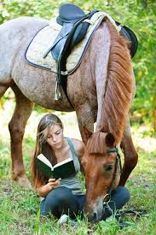

by Lansing RIF and
Beekman Therapeutic Riding Center
Summer Riding Camps 2018
First of all, choose a book.

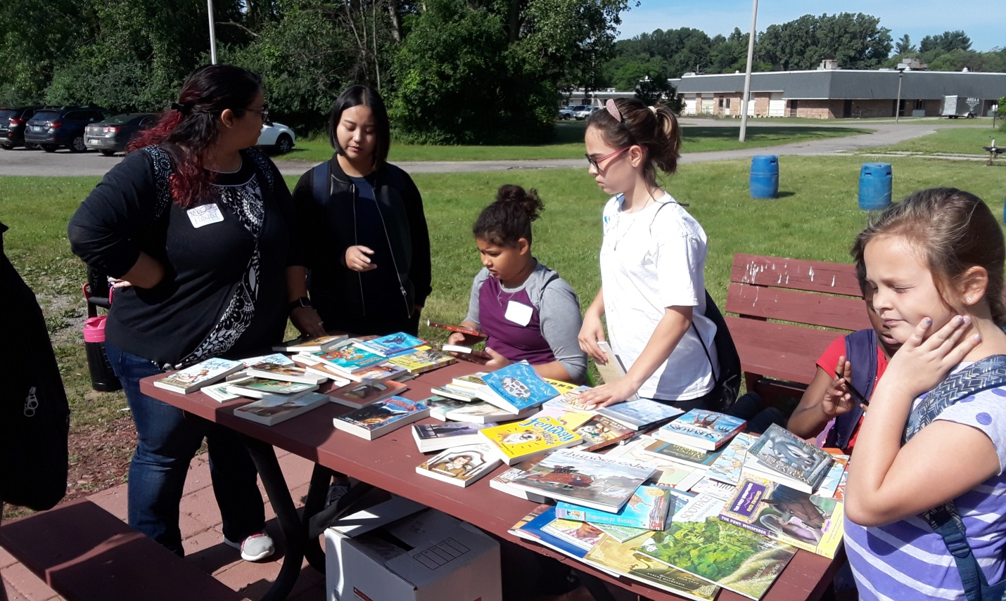
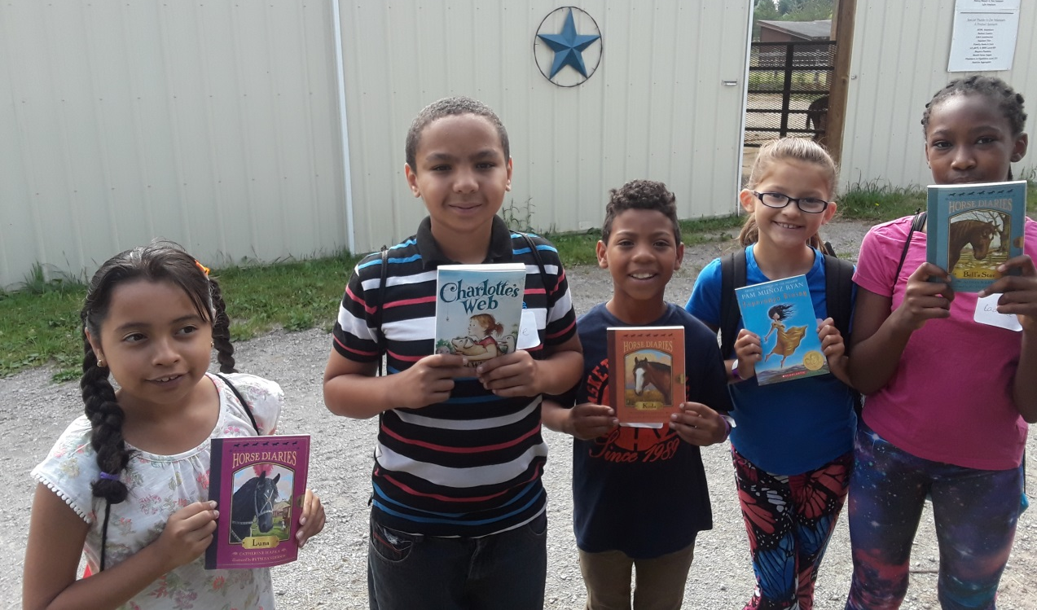
If you’re not sure what kind of book the horse would like, make sure you get one that you like.

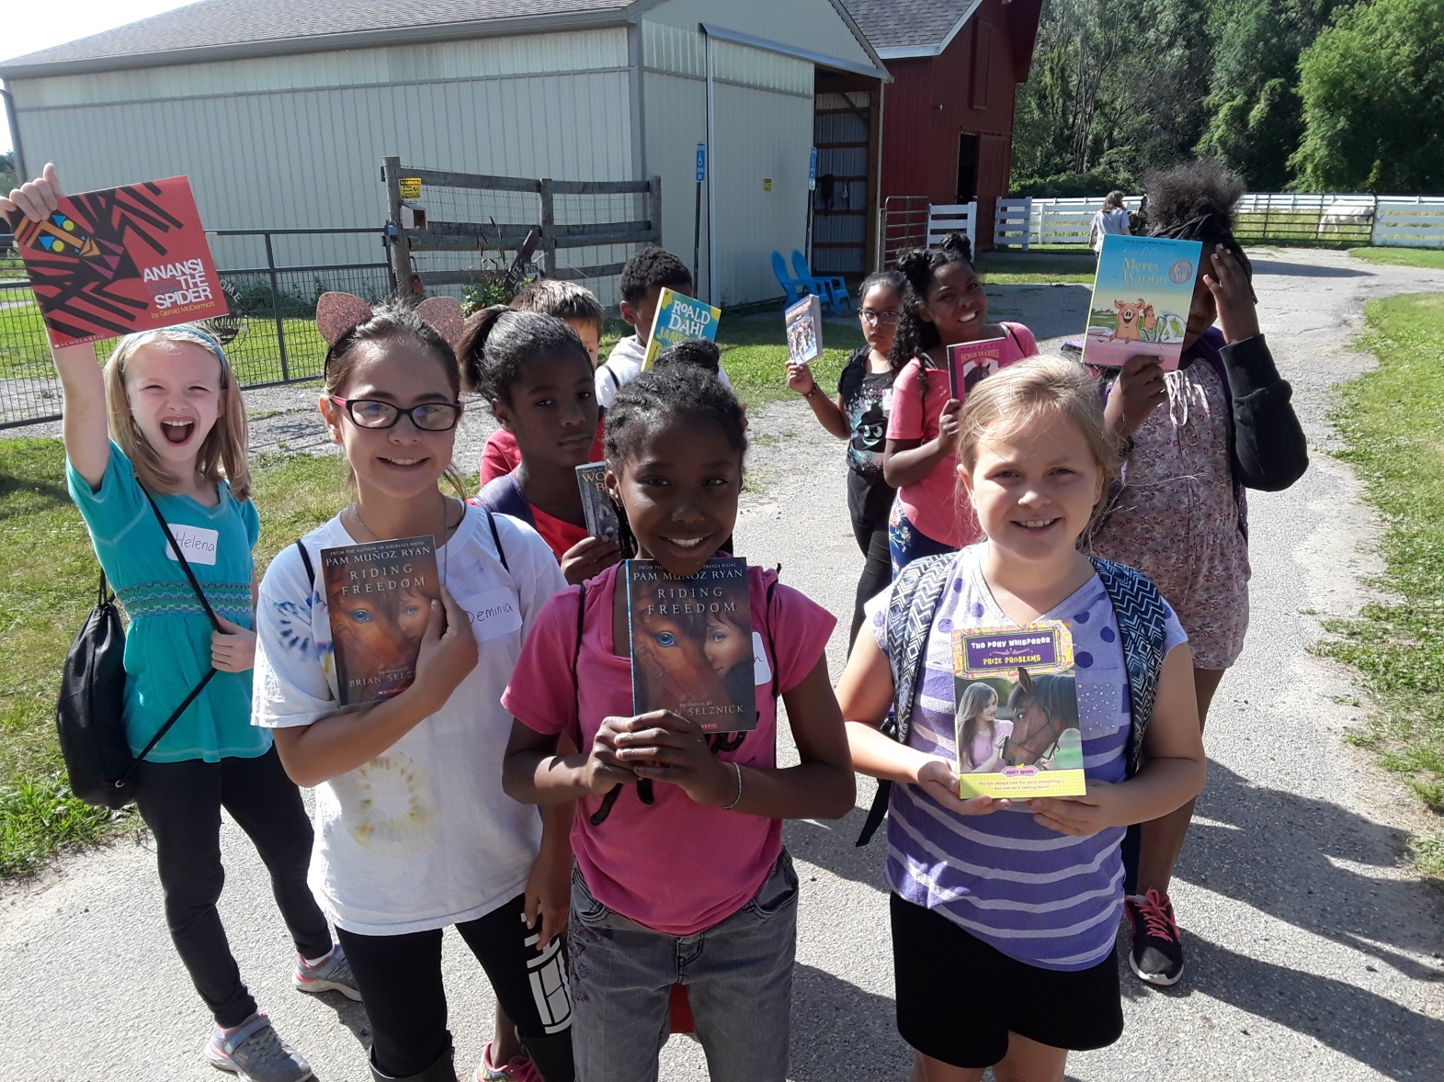

When you’re reading aloud, if you read a book you like, your audience is pretty sure to like it, too.

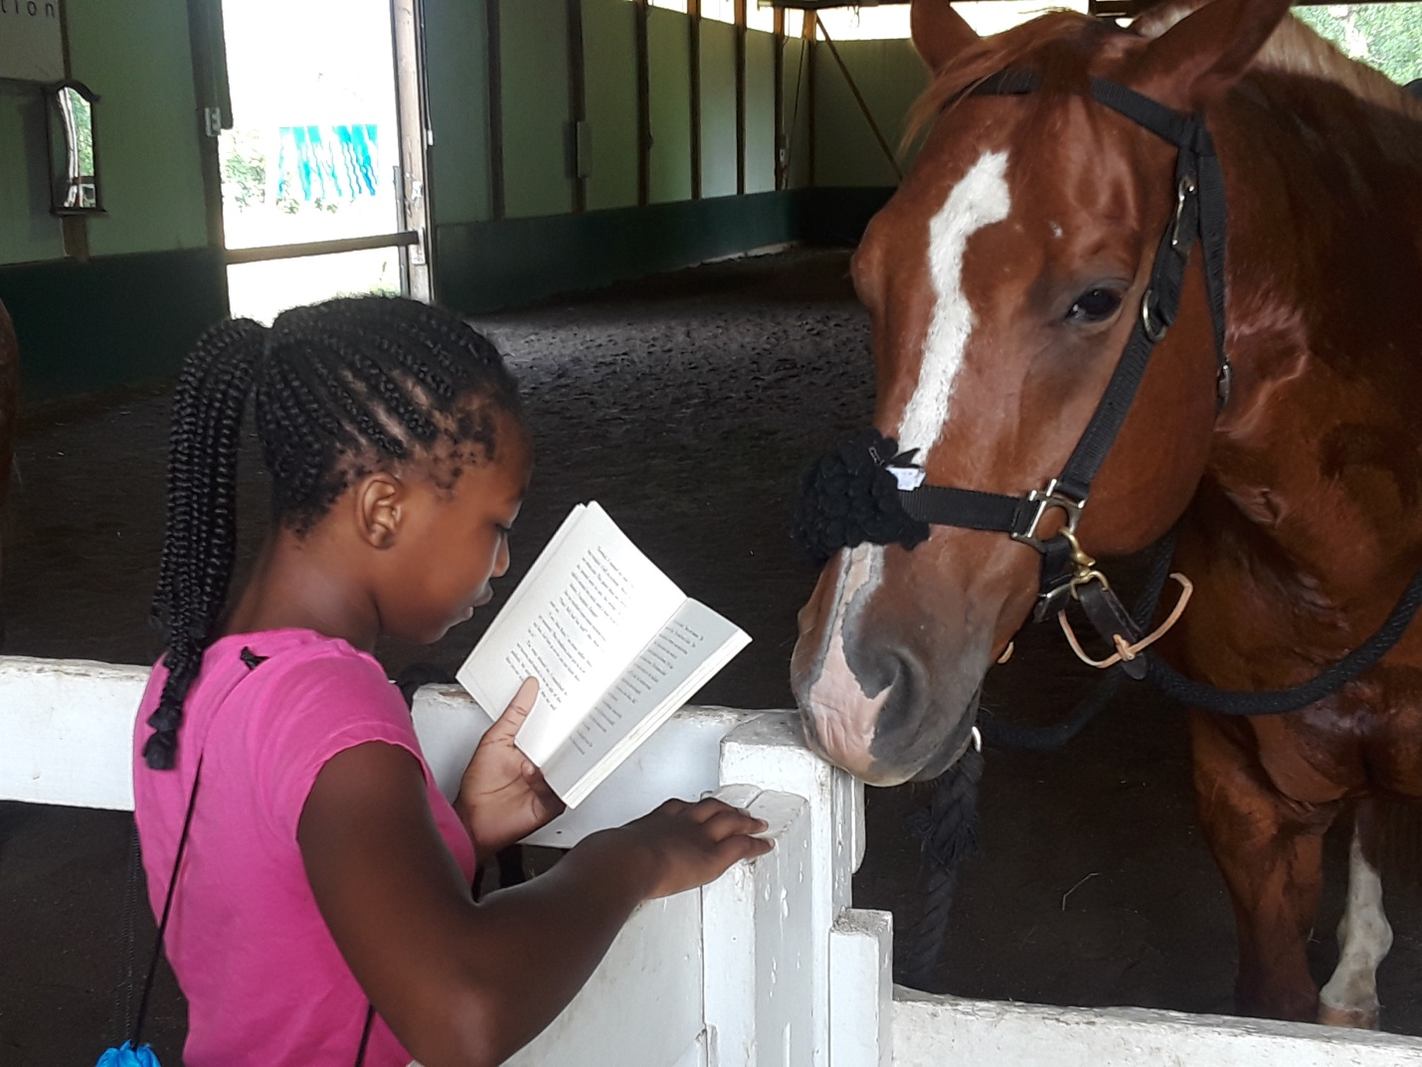

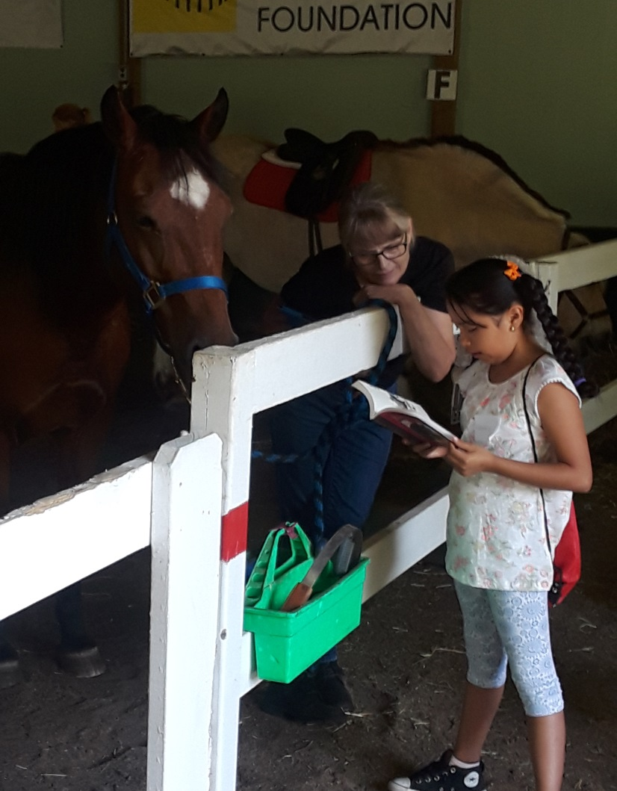
Look over the first page or two before you start.

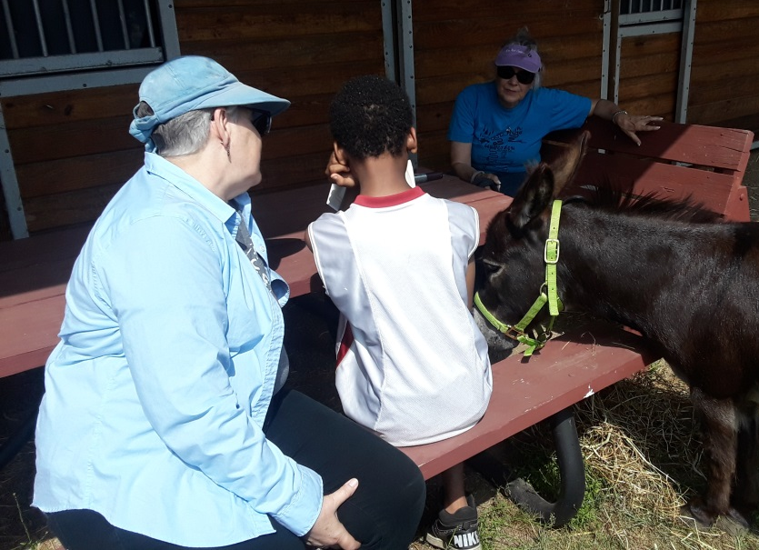

If there are words you don’t know, it’s perfectly fine to ask a friend!
Read loud enough for the horse to hear, but not so loud you scare it.

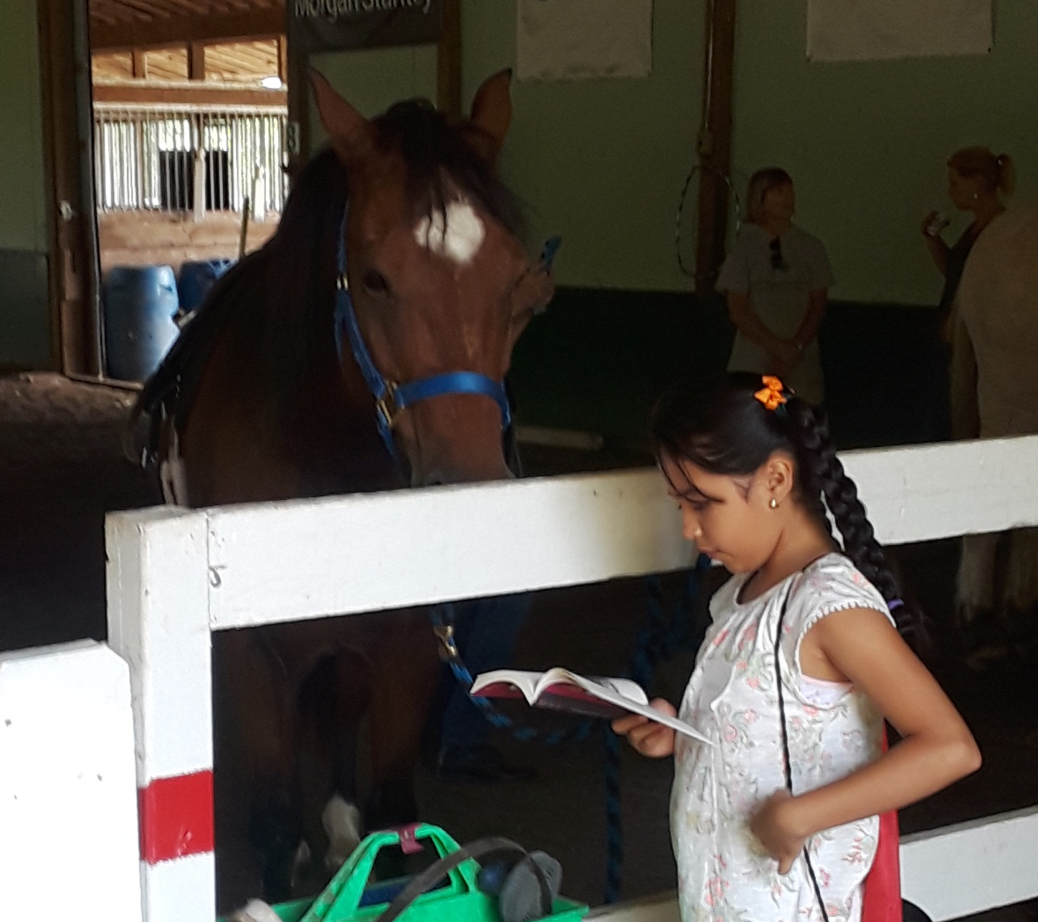

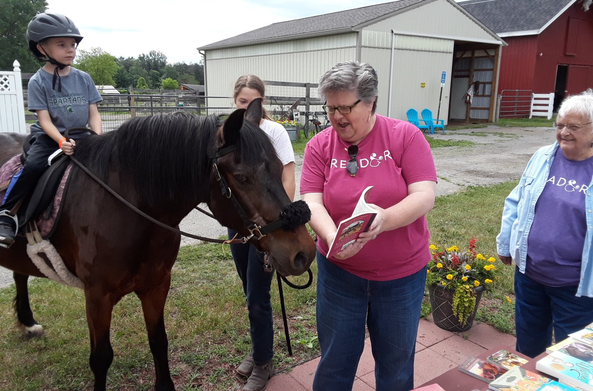
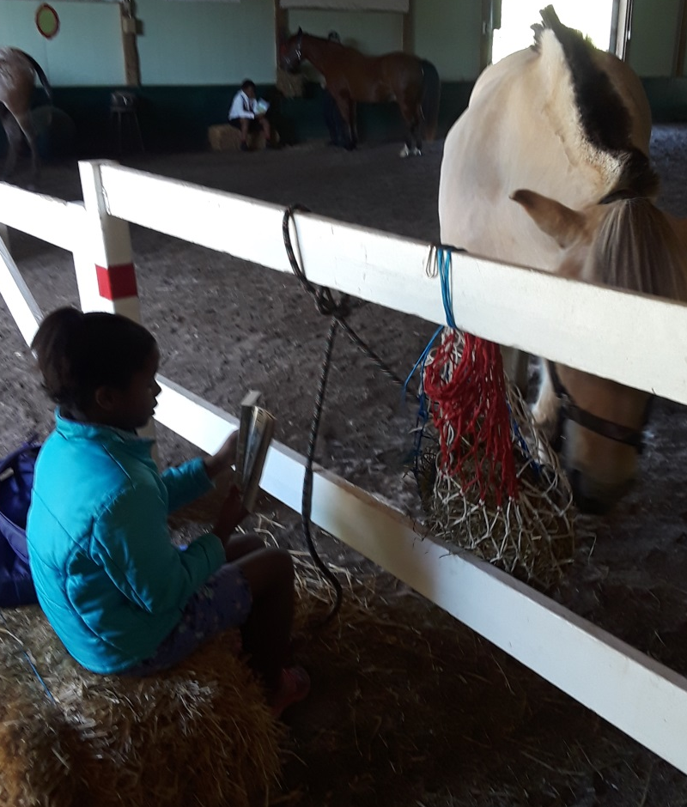
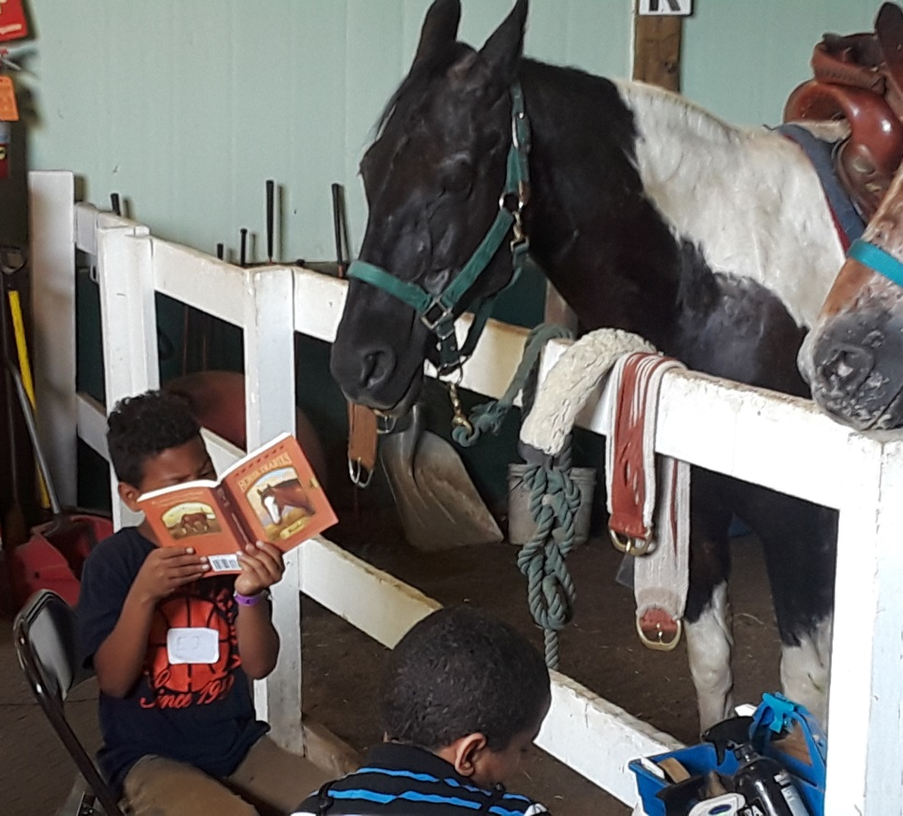
Don’t forget to show the horse the pictures.

The horse might be doing something else while you read--
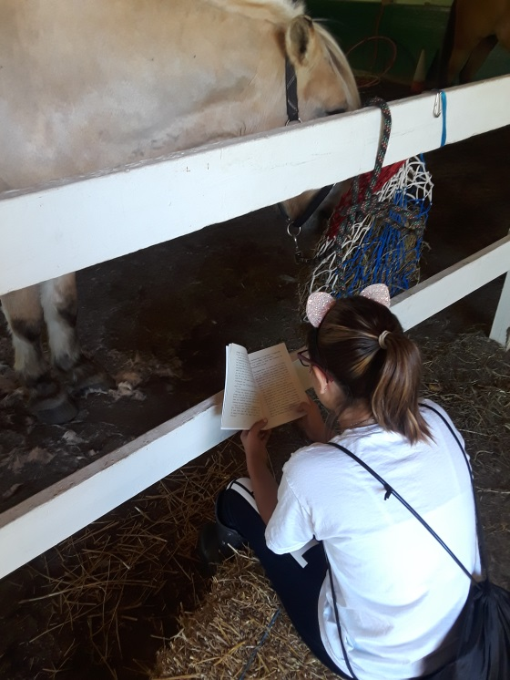

like eating,

or getting their hair done,
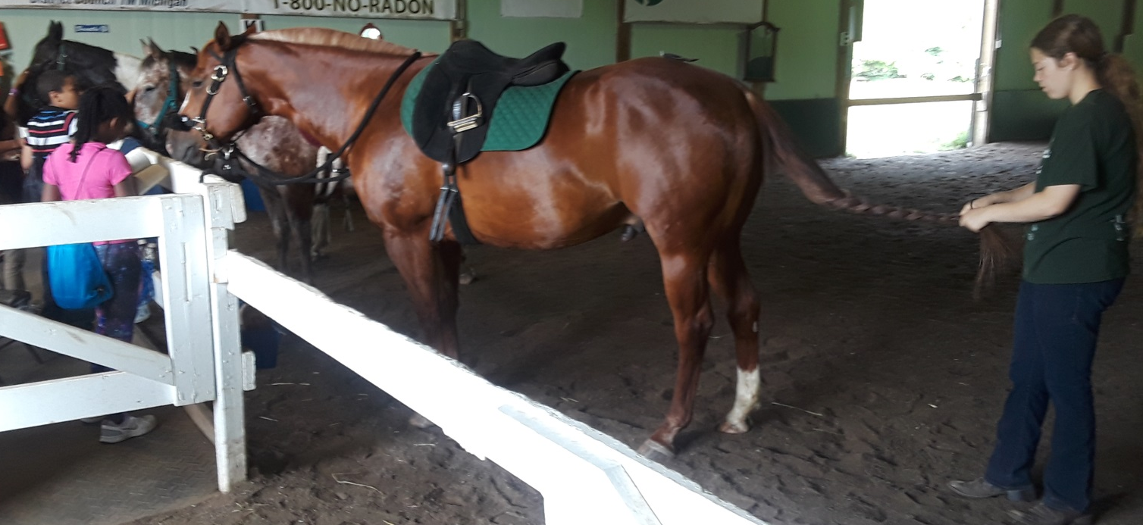

or stretching their legs.
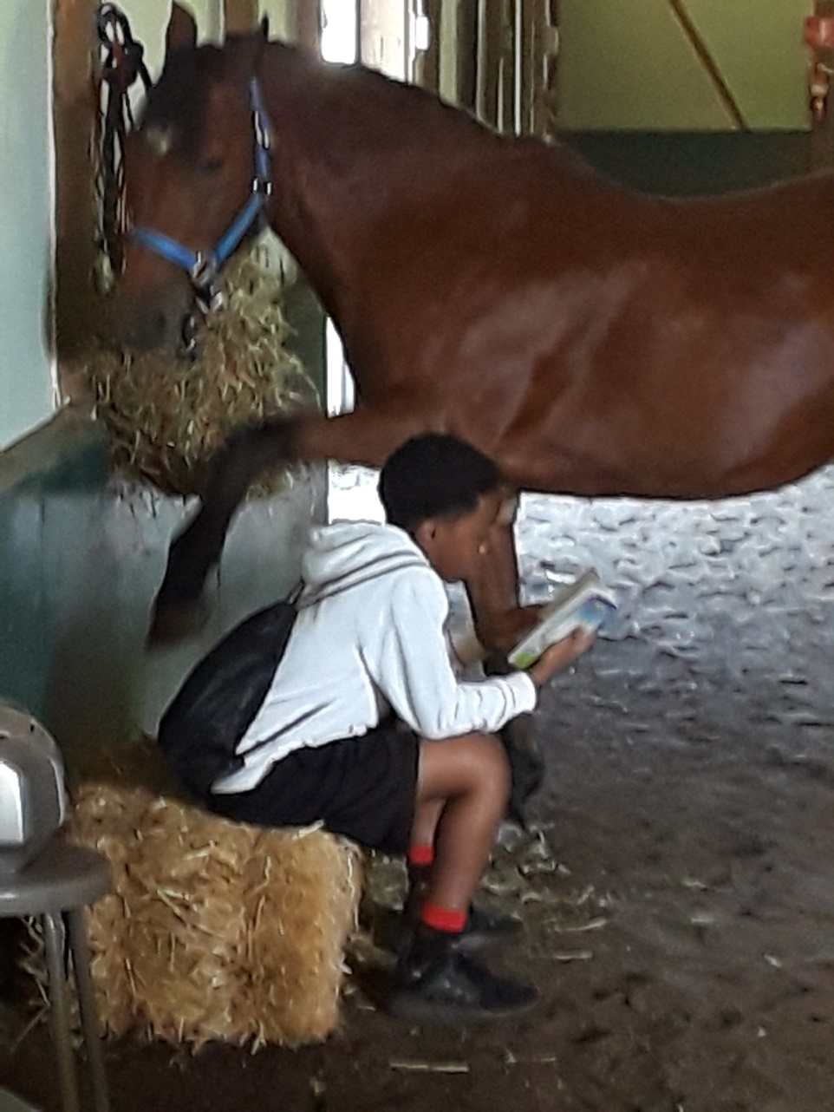

This doesn’t mean they are not listening. Just keep reading.

It’s a good idea to give the horse a friendly pat once in a while.

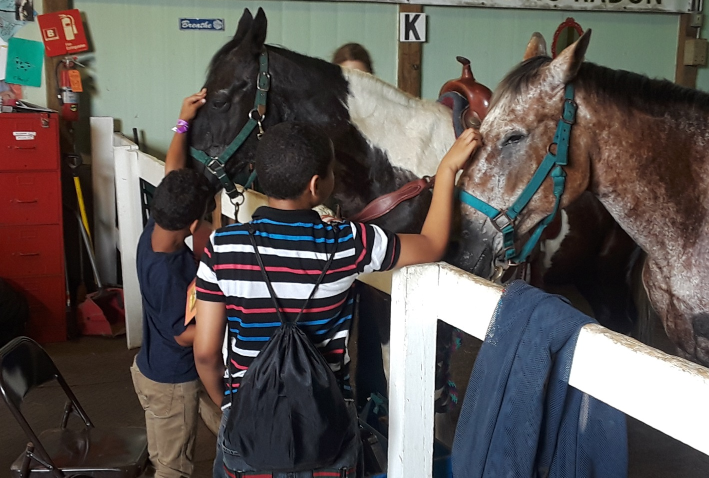

Then, when you get to ride the horse, you’ve already made a friend.
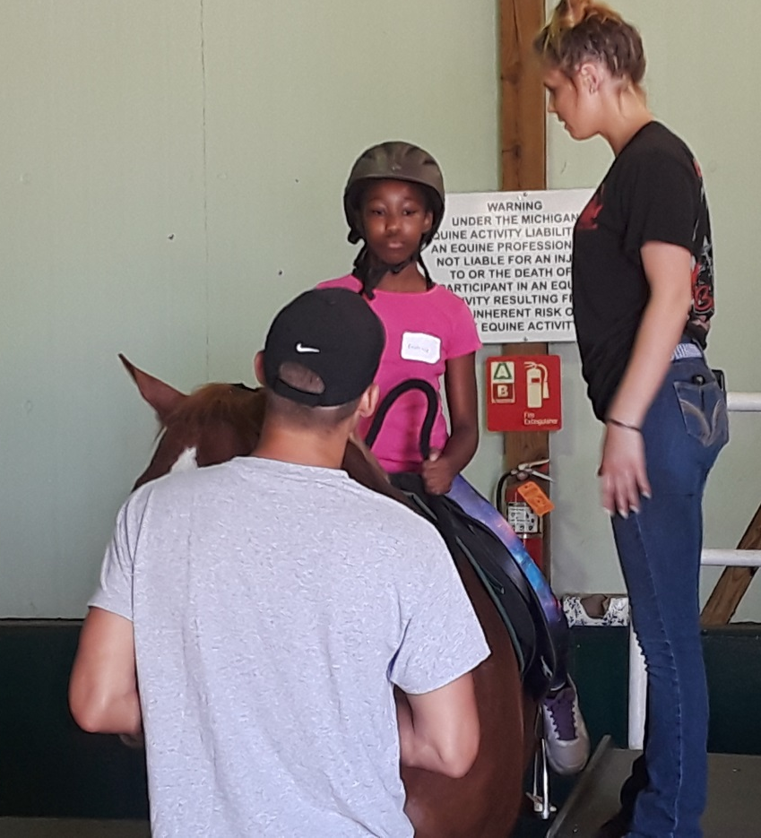

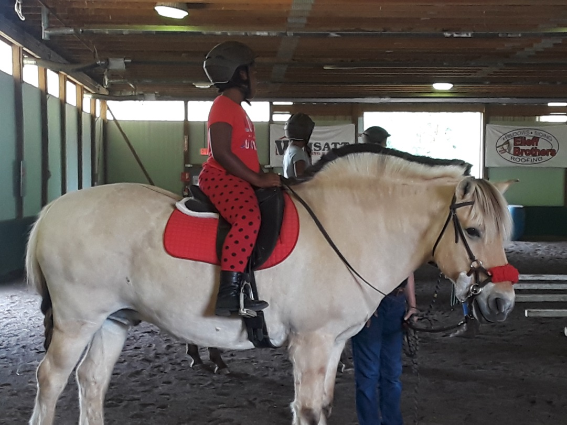

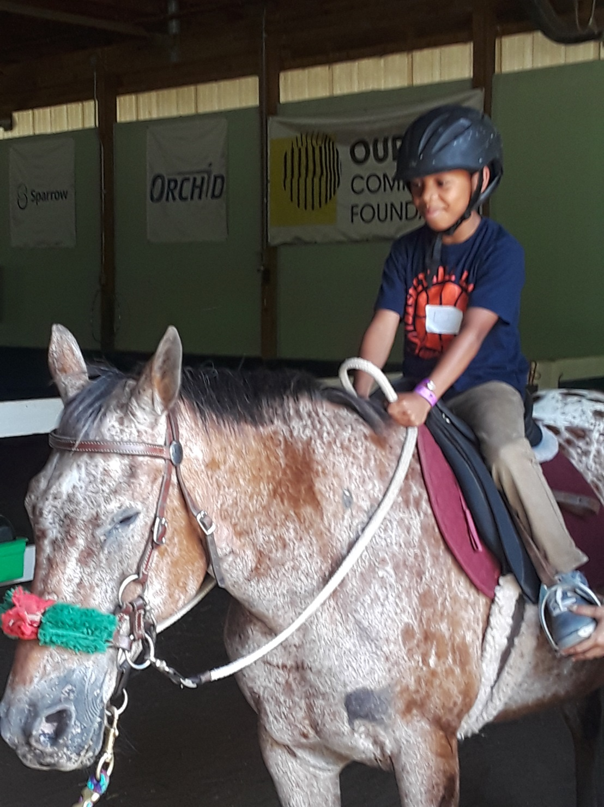

Reading can do that.

